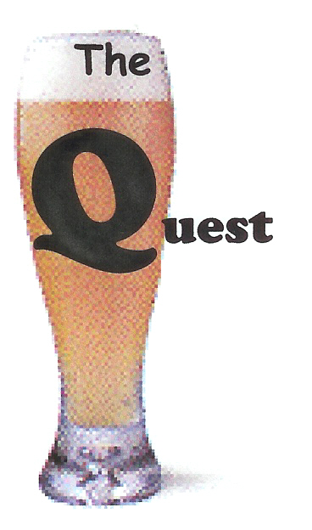
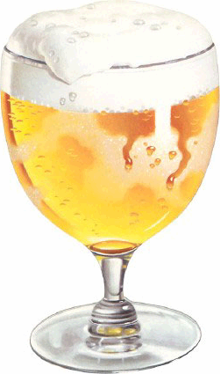
Quest for the Holy Grain

Notesheet for Brew Pub

Name of Establishment ____________________________________

- Number of Taps

- Number of Bottles, if any

- Diversity of Beers

- Notes

  - Bartenders (friendly, knowledgeable)
  - Clientele (age range, are they there for the beer?)
  - General Beer Philosophy (freshness, is it all about good beer?)

- Extras – JukeBox, Pool Table, peanuts, beer dinners

Brew Pubs

- Do they brew it right here?

- Other locations

- Beer quality, variety, sameness

- Can the beer be found anywhere else? Kegs? Bottles?

- Can I take home beer? (growlers, bombers)

- Size of brewing system (bbls)

