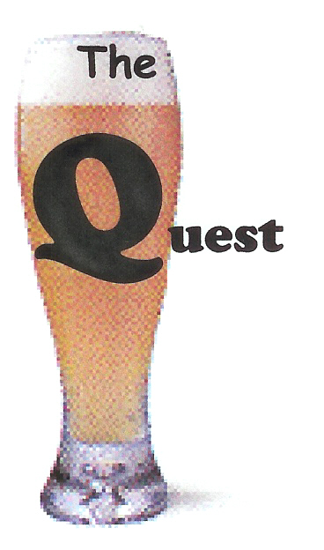
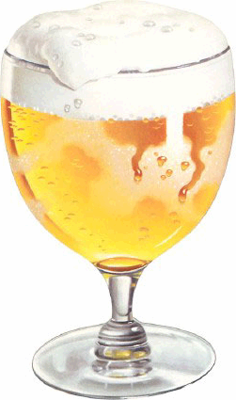
Quest for the Holy Grain

Notesheet for Beer Retailer

Name of Establishment ____________________________________

- Number of Taps (if any)

2. Growler fills

- Number of different beers offered

- Any food?

- Any other locations?

Retailers –

- Number of beers

- Helpful, knowledgeable salespeople

- Single bottles

- Mix a six?

- Taps, growlers, snacks?

