
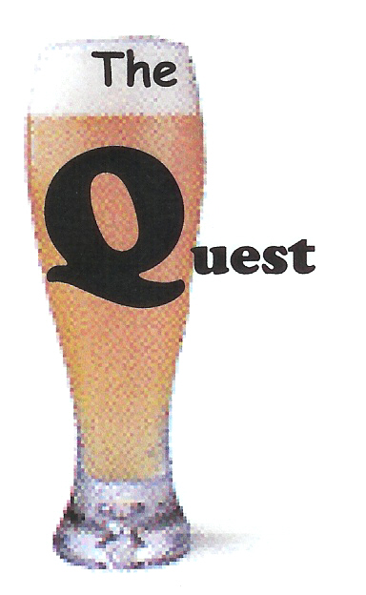

Quest for the Holy Grain
Beer Tasting ScoreSheet

Name of Beer
and ABV (% alcohol)
Judging Criteria
Presentation (5)
How did the beer look when it arrived? Consider choice of glass, head, color, & clarity.
Taste (25)
Chew the Brew. Consider Bitterness(back of tongue), Sweetness(front of tongue), Balance of the above, and Aftertaste, which may be a plus or a minus.
Body (10)
This category has been described as “mouthfeel.”
Consider robustness, carbonation, creaminess, and other sensations good or bad.

Drinkability (5)
Wait until almost finished, then ask, “Do I want another of these or would I just as soon switch?” Would you buy more?
You may also consider if the beer “grew on you” as you emptied your vessel.
Empty Glass Factor (5)
EGF
Set the glass down and view it. Judge whether or not the beer left its mark on the glass. A glass that appears to have been washed and sanitized scores low. High scores will show collar, lace, or legs.
Total (out of 50)
and
Comments

