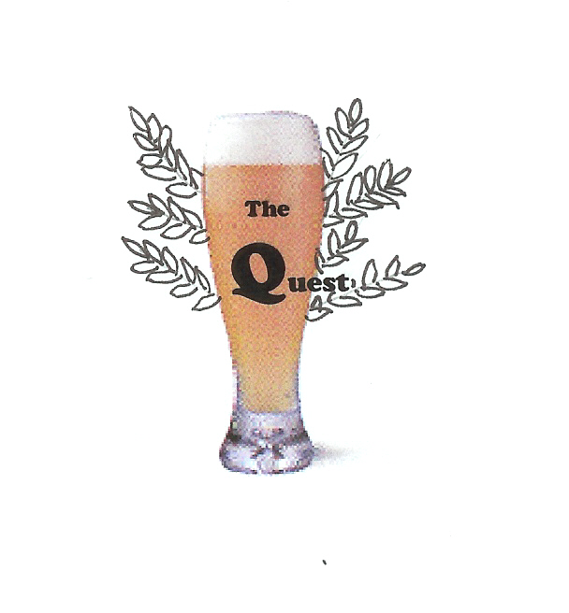
The Quest for the Holy Grain

Beer Rating Scoresheet – Alternate Version

Name of Beer | Date | Location | ABV | Score  from  0.1-10.0

